Math Mania 2022 - Final Review Handout

Answers

Module 1 Solutions:

Question 1:

1. 45 + (-29)  
     
   45dec = 0101101bin  
   29dec = 0011101bin  
     
   1100010bin <- one’s complement  
    1bin +  
   1100011bin = -29dec <- two’s complement  
     
    0101101bin <- 45dec  
    1100011bin + <- -29dec  
   10010000bin   
     
   discard left bit:  
   0010000bin = 16dec = 10hex
2. (-121) + (-19)  
     
   121dec = 01111001bin  
     
   10000110bin <- one’s complement  
    1bin +  
   10000111bin = -121dec <- two’s complement  
     
     
   19dec = 00010011  
     
   11101100bin <- one’s complement  
    1bin +  
   11101101bin = -19dec <- two’s complement  
     
    10000111bin  
    11101101bin +  
   101110100bin <- extra bit required (use two’s complement to convert to decimal)  
     
   101110100bin = -140dec = -8Chex
3. 207 + 97  
     
   207dec = 0011001111bin  
   97dec = 0001100001bin +   
    0100110000bin = 304dec = 130hex
4. (-156) + 141  
     
   156dec = 010011100bin  
   141dec = 010001101bin  
     
   101100011bin <- one’s complement  
    1bin +  
   101100100bin = -156dec <- two’s complement  
     
   101100100bin  
   010001101bin +   
   111110001bin  
     
   000001110bin <- one’s complement  
    1bin +  
   000001111bin = 15dec<- two’s complement  
     
   111110001bin = -15dec = -Fhex

Question 2:

1. $\sim \left(X+Y\right)⊕\sim \left(X ∙Y\right)→X ∙Y$ where X = 0, Y = 1
$$\left(\sim X ∙\sim Y\right)⊕\sim X+\sim Y →X ∙Y \\ \left(1 ∙0\right)⊕\left(1+0\right)→0 ∙1 \\ 0 ⊕ 1 →0 \\ 1 →0 \\ 0$$

2. $P ∙Q ⊕ R ↔P ∙Q+Q ∙R+R ∙R$ where P = 0, Q = 1, R = 0 $$\left(0 ∙1\right)⊕0 ↔\left(0 ∙1\right)+\left(1 ∙0\right)+\left(0 ∙0\right) \\ 0⊕0 ↔0+0+0 \\ 0 ↔0 \\ 1$$
3. $A+B ∙C →\sim A+A ↔1$ where A = 0, B = 0, C = 0 $$\left[\left(0+0\right)∙0 →1+0\right]↔1 \\ \left[0 →1\right]↔1 \\ 1 ↔1 \\ 1$$

Question 3:

$\sim \left(B+A\right)+B$ $$\left(\sim B ∙\sim A\right)+B \\ \left(\sim B+B\right) ∙\left(\sim A+B\right)←distributive \\ 1 ∙\left(\sim A+B\right)←complement \\ \sim A+B ←identity$$

|  |  |  |  |  |  |  |
| --- | --- | --- | --- | --- | --- | --- |
| **A** | **B** | **~A** | **~B** | **~A*~B** | **(~A*~B) + B** | **~A + B** |
| 0 | 0 | 1 | 1 | 1 | 1 | 1 |
| 0 | 1 | 1 | 0 | 0 | 1 | 1 |
| 1 | 0 | 0 | 1 | 0 | 0 | 0 |
| 1 | 1 | 0 | 0 | 0 | 1 | 1 |

$\sim \left(\sim A ∙B\right)\left(A+B\right)\sim A$ $$\left(\sim \sim A+\sim B\right)\left(A+B\right)∙\sim A ←DeMorgan^{'}s \\ \left(A+\sim B\right)\left(A\sim A+B\sim A\right) ←double negation and distributive \\ \left(A+\sim B\right)\left(0+B\sim A\right)←complement \\ \left(A+\sim B\right)\left(B\sim A\right)←identity \\ \left(A+\sim B\right)∙\left(B ∙\sim A\right) \\ (A ∙\left(B∙\sim A\right)+(\sim B ∙\left(B ∙\sim A\right)←distributive \\ \left(0 ∙B\right)+\left(0∙\sim A\right)←complement \\ 0+0 ←boundedness \\ 0$$

$XY+\sim \left(XY\right)+\left(X\sim X+X\right)$ $$XY+\sim \left(XY\right)+\left(0+X\right) ←complement \\ XY+\sim \left(XY\right)+X ←identity \\ 1+X←complement \\ 1 ←boundedness$$

$\sim \left(\sim A+\sim B\right)∙\left(\left(\sim A+\left(\sim A∙B\right)\right)+A\right)+\left(ABC ∙A\sim BC\right)$ $$\sim \left(\sim A+\sim B\right)∙\left(\sim A+A\right)+\left(ABC∙A\sim BC\right)←absorption \\ \sim \left(\sim A+\sim B\right)∙\left(\sim A+A\right)+\left(AC ∙\left(B∙\sim B\right)\right)←distributive \\ \left(\sim \left(\sim A+\sim B\right)∙1\right)+\left(AC ∙0\right)←complement \\ \sim \left(\sim A+\sim B\right)+0 ←boundedness and identity \\ \sim \sim A ∙\sim \sim B+0←DeMorgan^{'}s \\ A ∙B+0 ←double negation \\ A∙B ←identity$$

Question 4:



|  |  |  |  |  |
| --- | --- | --- | --- | --- |
| **P** | **Q** | **R** | **S** | **OUTPUT** |
| 0 | 0 | 0 | 0 | 0 |
| 0 | 0 | 0 | 1 | 0 |
| 0 | 0 | 1 | 0 | 0 |
| 0 | 1 | 0 | 0 | 0 |
| 1 | 0 | 0 | 0 | 0 |
| 0 | 0 | 1 | 1 | 0 |
| 0 | 1 | 0 | 1 | 0 |
| 1 | 0 | 0 | 1 | 1 |
| 1 | 0 | 1 | 0 | 1 |
| 0 | 1 | 1 | 0 | 0 |
| 1 | 1 | 0 | 0 | 1 |
| 1 | 1 | 1 | 0 | 1 |
| 1 | 1 | 0 | 1 | 1 |
| 1 | 0 | 1 | 1 | 1 |
| 0 | 1 | 1 | 1 | 0 |
| 1 | 1 | 1 | 1 | 1 |



|  |  |  |  |  |
| --- | --- | --- | --- | --- |
|  | **RS** | **~RS** | **~R~S** | **R~S** |
| **PQ** | 1 | 1 | 1 | 1 |
| **~PQ** |  |  |  |  |
| **~P~Q** |  |  |  |  |
| **P~Q** | 1 | 1 |  | 1 |



$Simplification:PQ+PR+PS$

1. P

Q  
  
P  
R  
  
P  
S

Module 2 Solutions:

Question 1:

$f\left(x\right)=\sqrt{\frac{3}{4}+3x}+7$

Domain:

$$\frac{3}{4}+3x=0$$

$$3x=-\frac{3}{4}$$

$$\frac{3x}{3}=-\frac{3}{4⋅3}$$

$$x=-\frac{1}{4}$$

Range:

$$f\left(x\right)=\sqrt{\frac{3}{4}+3x}+7$$

$$f\left(x\right)=7$$

D: $x≥-\frac{1}{4}$ R: $y≥7$

$g\left(x\right)=\frac{2}{1+\frac{x}{4}}-2$

Domain:

$$1+\frac{x}{4}=0$$

$$\frac{x}{4}=-1$$

$$\frac{4⋅x}{4}=-1⋅4$$

$$x=-4$$

Range:

$$g\left(x\right)=\frac{2}{1+\frac{x}{4}}-2$$

$$g\left(x\right)=-2$$

D: $x≠-4$ R: $y≠-2$

Question 2:

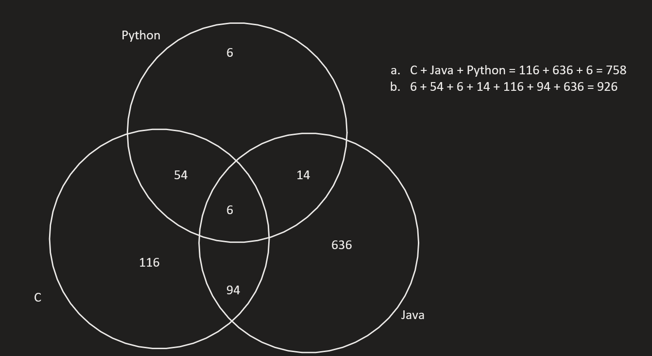

Question 3:

a0 = 9

a1=

a2=

Question 4:

$\sum_{i=-1}^{3}{\left(i^{2}+2\right)}$

i = -1: 3

i = 0: 2

i = 1: 3

i = 2: 6

i = 3: 11

$$\sum_{i=-1}^{3}{\left(i^{2}+2\right)}=25$$

$\sum_{m=-1}^{2}{\left(\frac{m^{3}-1}{m^{2}+1}\right)}$

m = -1: -1

m = 0: -1

m = 1: 0

m = 2: $\frac{7}{5}$

$$\sum_{m=-1}^{2}{\left(\frac{m^{3}-1}{m^{2}+1}\right)}=\frac{-3}{5}$$

Question 5:

Question 6:

1. 2,8
2. 1
3. 8, 9, 10, 11, 12
4. Height = 3
5. 7 internal vertices (1, 2, 3, 5, 6, 7)

Module 3 Solutions:

Question 1:

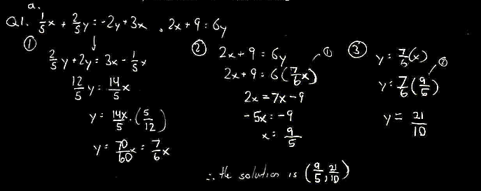

b)   
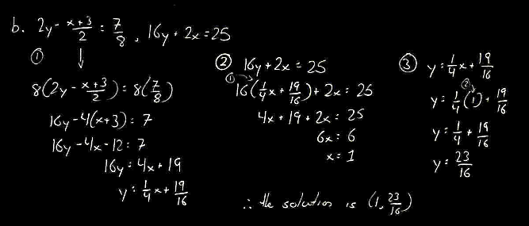

Question 2:

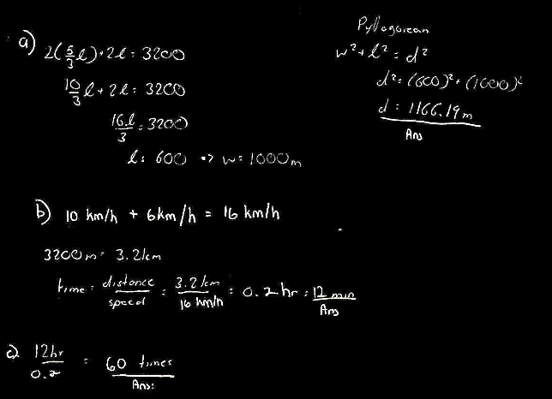

Question 3:

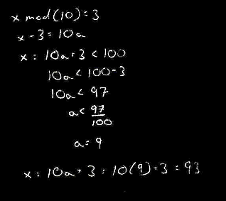

Question 4:

1. Let number be x

½(x)+3 = 5. (6-2)

½(x)+3 = 20

X = 34

1. Let the number be x

¼(x+3) = 8*2-1

X=57

1. Sqrt(x+2)=16-7

Sqrt(x+2) = 9

X+2 = 3

X=1

Or

X+2 = -3

X=-5

But this is not possible as we can’t put the negative value in root

Module 4 Solutions:

Question 1:

1. AC-B
2. 3A+BC

a)AC= $\begin{matrix}20 & -88 & 120 \\ -16 & -127 & 316 \\ -224 & -107 & 324\end{matrix}$

AC-B = $\begin{matrix}25 & -95 & 108 \\ -12 & -112 & 302 \\ -219 & -99 & 323\end{matrix}$

b)BC = $\begin{matrix}221 & 68 & -81 \\ -75 & 147 & -225 \\ -147 & 36 & -13\end{matrix}$

3A+BC = $\begin{matrix}232 & 89 & -108 \\ -102 & 192 & -264 \\ -186 & 51 & -58\end{matrix}$

Question 2:

1. Inverse of p $\begin{matrix}5/36 & 1/18 \\ -1/12 & 1/6\end{matrix}$
2. Inverse of A $\begin{matrix}-1/142 & -7/71 & 25/213 \\ -9/142 & 8/71 & 4/71 \\ 15/71 & -3/71 & -40/213\end{matrix}$

Question 3:

b)

Question 4.

Answer -

4*=

Question 5:

Question 6:  
a)  
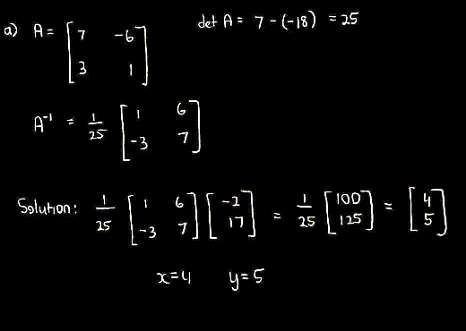

b)  
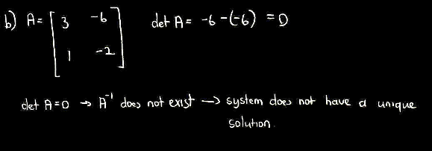

c)  
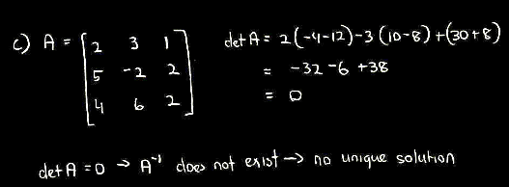

d)

Question 7:  
a)

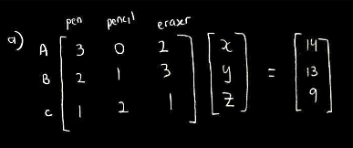

b)

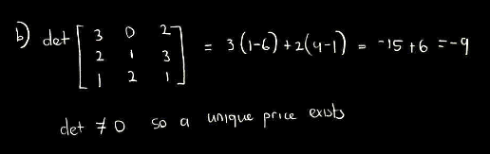

c)

